Name ____________________________ HOMEWORK Sept. 26-30
Put your initials by each night that your child practiced the following:
____Monday ____Tuesday ____Thursday
*Nightly Homework*
1. Practice saying letter names and sounds.
2. Count numbers 1-25.

Say the following letter names and sounds.
Mm Ss Tt Bb Aa

Monday- Count and circle the number of syllables in each word.
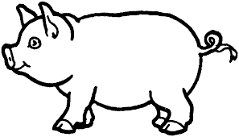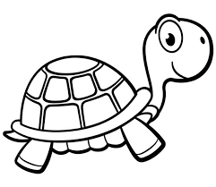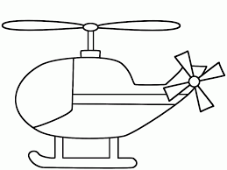

1 2 3 4 1 2 3 4 1 2 3 4 1 2 3 4

Read it. Trace it. Write it.
am am ______
at at ______
go go ______

Tuesday – Write the beginning sound for each word.

________ _________ __________ __________
Thursday-
Draw 2 pictures that have the short a sound that you hear in cat, and 2 pictures that have the long a sound like you hear in cake.
Short a | Long a

Color the smiley face if the 2 words in the box rhyme. Color the sad face if the 2 words in the box do not rhyme.
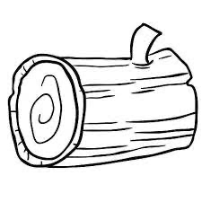 | 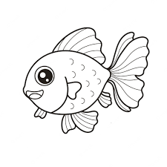

Start Right Reader
Words to Know
am at go

At Bat

See Sam at bat.
Bam! Go, Sam!
See the ball go!
See the bird!
Bam!
See Tab catch the ball!

